**HEALTH STREETH HOSPITAL**

**HOSPITAL MANAGEMENT SYSTEM**

Diploma In Software Engineering 20.1 Full Time

Bishan Kanthana - MA-DSE-201-F-007

Chalitha Basula - MA-DSE-201-F-009

Hasindu Nimsara - MA-DSE-201-F-010

Hansaka Tharanga -MA-DSE-201-F-041

National Institute Of Business Management

**Declaration**

“I certify that this project does not incorporate without acknowledgement, any material previously submitted for a Diploma in any institution and to the best of my knowledge and belief ,it does not contain any material previously published or written by another person or myself except where due reference is made in the text. I also hereby give consent for my project report, if accepted, to be made available for photocopying and for interlibrary loans, and for the title and summary to be made available to outside organizations”

Index no Name Signature

MA-DSE-201-F-007 Bishan Kanthana .…………………

MA-DSE-201-F-009 Chalitha Basula .…………………

MA-DSE-201-F-010 Hasindu Nimsara .…………………

MA-DSE-201-F-041 Hansaka Tharanga .…………………

………………. …………………………

Submission Date Mrs. Nadeeshani Gunasekara

Course Director

**Acknowledgement**

It is indeed with a great pleasure and immense sense of gratitude that we acknowledge the help of these individuals. We are highly indebted to our Course Director Mrs Nadishani Gunasekara for the facilities provided to accomplish this DSE final project. she has been a constant source of inspiration for us and we are very deeply thankful to her for her support and valuable advice. We extremely grateful to our National School of Business Management staff members, Lab technicians and Non-teaching staff members for their extreme help throughout our project. Finally we express our heart full thanks to all of our friends who helped us in successful completion of this project.

**Table of Content**

**Chapter1-introduction**

Introduction…………………….………………………………………....Page 01

* 1. Background…………………………………………………....……….Page 02
  2. Statement to problem…………………………………………....……Page 04
  3. Aim and Objectives…………………………………………...………Page 05
  4. Scope of Study……………………………………………………….Page 06
  5. Gantt Chart……………………………….…………….………….…Page 08

**Chapter 2-Analysis**

2.1 Existing System…….……………………….………………….…….… Page 09

2.2 Major Activities and Functions……………………...……………….…...Page 11

2.3 Drawbacks of Existing System ………………...…………...…...………Page 15

2.4 UML Diagrams……….……...…………………………………...….... Page 16

2.4.1 Use Case Diagram………………………………………page

2.4.2 Activity Diagram………………………………………..page

2.4.3 Class Diagram…………………………………………..

2.4.4 ER Diagram……………………...

**Chapter 3-Design**

3.1 Proposed System……………………………………………………………page

3.1.1 System Requirements……………………………………………………page

3.2 Database Design……………………………………………………………page

3.3 Interface Design……………………………………………………………..page

3.4 Report Design…………………………………………………………………..page

3.5Message Boxes………………………………………………………………….page

**Chapter 4-Conclusion**

**CHAPTER 1**

**Introduction**

Information technology is made people’s lives easier.Thats’s why With the birth of information technology, new machines and new technologies are introduced to the world. Today, Information technology is became the turning point of the world. Most of countries used many concepts related with information technology to do their day to day activities.

In Sri Lanka, both government sector and private sector institutes like banks and universities used new technologies to make their day to day works. What we are particularly considering here is a unique way of systematically entering and storing information in a hospital. The hospital is an essential place for every person living in the world, so the information of the hospital staff as well as the people who come to work in the hospital should be stored in a very secure and systematic system.

But To keep the information related with all other hoapital related activities, they used paper documents. There are so many drawbacks of using paper documents to store important data. The one of main drawback is loss of security. The paper documents can be damage or destroy by animals, fires, natural disasters and so on. And also these documents can be stolen by someone. Sometimes paper documents can be lost or misplaced. Lack of paper storage is another drawback. Paper documents take a significant amount of space, therefore to store large amount of data, many papers must be used. Transporting documents in a paper based system is taking complicated, slow and inefficient. It is another drawback. If someone wants to make changes in a paper document, he or she will need to write all the content again. This will need to be repeated every time that someone wants to make more corrections. The person who make correction should make a copy of the original document to distinguish all the amendments that have be done. High cost is another main drawback. To store data, the tones of paper documents must be used with pens, printers, photocopies and etc. So it makes a high cost. Environmental damage is another drawback.

**1.1 Background**

Our developers decided to introduce a hospital management system as a solution to these problems which can be seen as inefficient in the hospital sector due to the above reasons. It consists of the following subsystems.

* Admit Patient Management System
* Admit Patients dashboard
* Add New Patient
* add Guardians
* Guardians dashboard
* Addmition officers
* X-ray out patients
* X-ray in patients
* Change password
* Doctor dashboard
* Patients lab sample
* Officer
* Organization
* Add pharmacy Medicines
* Suppliers
* Scan patients samples
* Scan patients
* Room dashboard
* Add customer

The hospital management system consisting of these subdivisions provides a high quality, safe and quality service to the people free from the aforementioned unsafe practices.

We also hope to create a website parallel to this hospital management system. The hospital management system provides a detailed description of the hospital that owns the hospital management system belongs, even though all activities in the hospital are carried out systematically.

The user of this website can get a better understanding of the hospital. For example, the history of the hospital, the details of the doctors treating the hospital as well as the diseases treated by the hospital can be give This website also allows anyone to make an online book apology so that the person who comes to get the service from the hospital can get the service they need on time without any wastage or hassle

**1.2 Problem Statement**

Here we see that the main problem is that all the activities in the hospital system are going on without any management. There are many disadvantages to this method

Paper documents take up considerable space. So a lot of paper should be used to store information on a daily basis. So there are millions of papers every month and at the end of the year. Therefore a large area is required to store all paper documents.

This paper writing system is expensive. To store a lot of information, the hospital needs to spend a lot of money to buy paper, books, pens, printers, photocopies, and so on.

Furthermore, Paper documents cannot provide a proper security for the data. Because paper documents can be easily damaged by animals, fires, natural disasters and many of other harmful activities. And also these papers can be lost or misplaced. So it is unable to find the papers quickly. It is time wastage. Sometimes any one can steal any information because of the lack of security.

This system is consisted with many disadvantages. So it makes hospital works inefficient. So we can clearly understand this paper document system is not suitable for school in the modern society. Because present society is developed with new technological concepts.

* + 1. **Aim and Objectives**
       1. **Aim**
* goal is to facilitate to make the work of the hospital more efficient and patients to be able to channel the doctor they want without having to go to the hospital. This way patients are not rascals. You can come in time and channel the doctor. It saves them time and effort.
  + - 1. **Objectives**

To reach for our aim, we have several objectives to complete.

* Clearly identify the drawbacks of current system.
* Find the best solutions for each identified draw backs
* Design a system for better patient care.
* Reduce hospital operating costs.
* Provide Management Information System report on demand to management for better decision making.
* Better co-ordination among the different departments.
* Provide top management a single point of control

**1.4 Scope of Study**

**HEALTH CARE HOSPITAL Management System**

We know that many rural hospitals do not have a proper system to manage day-to-day hospitals and other administrative matters. Our main hope is to establish this system in hospitals throughout the island.

Paper sheets are usually used to store information here. It is an unsafe method that increases the risk of data loss and causes inconvenience to patients as well as hospital staff. This is because it takes up a lot of space and it fails because it is difficult to transport

Through our system, we hope to manage all activities using new technological concepts. Patients and their caregivers use the patient's medical reports, staff and database of physicians, officers, suppliers, and pharmacies currently available at the hospital pharmacy.

We hope to manage everything in this section, including category information. Therefore, anyone can take the time to see a doctor without going to the hospital, which is very convenient for patients as well as hospital staff.

We hope to set up an “IT room” with the authorized person who manages the above system. So anyone can take any report of patients in a matter of seconds.

We also hope to keep the unit up to date with all the information about the doctors when they arrive. Under this we can easily know the doctor we want according to the need or what disease that doctor is special for.

Under this system we can see how many patients are currently being treated in the hospital, how many patients are coming in a day and the number of doctors in the hospital at that time and also the information of the staff working in the hospital which is very important for the administration of the hospital. Patients can also find out which treatments they received at the hospital and which doctor they saw.

Our hospital management system is able to manage all hospital activities with the help of new technologies. We look forward to the successful completion of the system and to establish our "Hospital Management System" in hospitals to make all hospital activities and all other activities a single computer-based platform for the smooth management of all hospital operations. Technology by providing an efficient and optimal medical environment by minimizing the problems of the current paper writing system Finally, we have a dream to introduce this system to hospitals across the island.

**1.5 Gantt Chart**

|  |  |  |  |  |
| --- | --- | --- | --- | --- |
| **Task** | **June** | **July** | **August** | **September** |
| Requirement gathering |  |  |  |  |
| Design |  |  |  |  |
| Coding |  |  |  |  |
| Testing |  |  |  |  |
| Maintenances |  |  |  |  |

**CHAPTER 2**

**2.1Existing System**

Existing System Hospitals currently use a manual system for the management and maintenance of critical information In Hospital Management System, presently all Patients and staff

Management operations are being done manually. Various Books and Regersome and time consuming, as even for a single Record, several books must be referred, in all immediate updating, validation, and reporting is just too large.

If someone wants to make changes in a paper document, he or she will need to write all the content again. This will need to be repeated every time that someone wants to make more corrections. The person who make correction should make a copy of the original document to distinguish all the amendments that have be done. And also, to make the old document correction, it is unable to find the document quickly. Because there are lot of documents. It is a trouble with time wastage.

To transporting documents in a paper-based system is taking complicated, slow and inefficient.

The current system requires numerous paper forms, with data stores spread throughout the hospital management infrastructure. Often information (on forms) is incomplete or does not follow management standards. Forms are often lost in transit between departments requiring a comprehensive auditing process to ensure that no vital information is lost. Multiple copies of the same information exist in the hospital and may lead to inconsistencies in data in various data stores. Objective of the System Hospitals currently use a manual system for the management and maintenance of critical information. The current system requires numerous paper forms, with data stores spread throughout the hospital management infrastructure. Often information (on forms) is incomplete or does not follow management standards. Forms are often lost in transit between departments requiring a comprehensive auditing process to ensure that no vital information is lost. Multiple copies of the same information exist in the hospital and may lead to inconsistencies in data in various data stores. A significant part of the operation of any hospital involves the acquisition, management and timely retrieval of great volumes of information. This information typically involves; patient personal information and medical history, staff information, room and ward scheduling, staff scheduling, operating theater scheduling and various facilities waiting lists. All this information must be managed in an efficient and cost wise fashion so that an institution's resources may be effectively utilized HMS will automate the management of the hospital making it more efficient and error free. It aims at standardizing data, consolidating data ensuring data integrity and reducing inconsistencies.

This result in unnecessary delay in various operation of organization and cloisters are maintained for entries about patients and staff enquiry, registration and fees submission. Final report preparation is very combed be detrimental to the progress. This result in unnecessary delay in various operation.

Paper documents take a significant amount of space. So, to store day to day information many papers must be used. So, at the end of each month and year, there are millions of papers. So, it wants the large area to store all paper documents.

This paper document system makes a high cost. Because to store much information, hospital must want to buy papers, books, pens, printer machines, photocopies and so on by expensing lot of money.

**2.2 Major Activities and Functions**

To give a solution for the drawbacks of current paper-based hospital management system, we will hope to introduce the new system called “health care hospital Management System” which is consisted with many useful digital technological concepts. By using this system, we hope to take all activities of the hospital to a one computer-based platform to manage hospital works with more efficiently.

We divided our system into many sub parts. So, we can give a suitable solution for each section of the hospital easily.

**1. Admit Patient**

This section is used to enter patient and patient guardian details. First Name, Middle Name ,Surname, date of birth ,reason and gender into patient. patient guardian details are name, Nic, Address, TP Number , Relationship, date and time.

**2.Admit Patients Dashboard**

Patients admitted to the hospital by this section shows the in Patient id number, Patient first name , Patient middle name, patient surname, Gender , Date of birth, Age, Blood Group, Guardian NIC, Guardian Address and Guardian TP No in in admit patient in the hospital.

**3.Add New Patient**

This section is used to add new patient. Add to Patient Name, guardian TP No , Guardian NIC , Age , reason. And add the patients guardians details. The details are Name, Nic, Address, TP Number, Relationship, Date , Time.

**4. Add Guardians**

This section is used to add the Guardians details. There are Name, NIC, Address, TP Number , Relationship ,date and time.

**5. Guardians Dashboard**

This section is used to show the Guardians details. There are Name, NIC, Address, TP Number , Relationship ,date and time.

**6.Customer Dashboard**

This section is used to show the invoice Number , Appointment Number , Consultant Name , Specialist Doctor id , Session Date , Patient Name, Contact Number , hospital fee.

**7.Addmition Officers**

This section is used to display the addmition officers and officer can have seen the admit patients.

**8.X-ray Out Patients**

This section is used to out the x-ray of the patient. The details are X ray No , Patient id Number , x ray and issue Date and issue time .

**9.X-ray In Patients.**

This section is used to in the x-ray of the patient. The details are X ray No , Patient id Number , x ray and issue Date and issue time.

**10.Change Password**

Custermized details all login users. Details are first Name, Last name, G-mail, New Password, confirm Password.

**11.Doctor Dashboard**

This section shows the doctor details. the details are First Name , Middle Name , Surname, gender , Address, TP Number , designation , salary and another part is work done by the doctor during the last two months. shows in-patient , out-Patient, Appointment of the doctor.

**12.Patients Lab Sample**

This section shows the in-patient sample and and out-patient samples.in patient sample details are Sample in number, Patient id Number, ward Number, Room number, specialist doctor id , laboratory Staff id , received Date , Received Time. Out-Patient samples data are Sample out Number , Patient id Number , Sample Type , Specialist Doctor id , Laboratory Staff id , Received Date, Received Time.

**13.Officer**

This section shows all details in officers . the details are Roll no, First Name, Middle name , surname, gender, Address , Tp Number , Designation , Salary.

**14.Organization.**

This section is showing all details are government Organization . The details are Government Reg Number , Organization Name, Organization Address, Bill Number , Billing Officer id.

**15.Pharmacy Dashboard**

This section shows all details of the pharmacy. The details are drug code, drug Name , Drug Price , supplier id , supplier Name , Manufacture company , Manufacture Reg Number.

**16.Add Pharmacy Medicines**

This section shows all details of the pharmacy medicines the details are Drug Name, trade number , Store Place , drug Price, date , Time.

**17.Suppliers**

This section shows Supplier ID, Supplier Name , Manufacture Company , Manufacture counter , manufacture Reg Number , Drug Name , Supply quantity.

**18.Scan Patients Samples**

This works in two sub-parts in patients samples and out patients samples. In patients samples details are scan no, admission number , scan report, issue date , ward Number , room number , Specialist Doctor id. Out patients Samples details are Out Patients Scan No, Patient Id Number , Scan Report , issue Date , Issue Time , specialist doctor id.

**19.Scan Patients.**

This works in two sub-parts add scan inpatients and add scan out Patient. Add scan inpatient add details are Addmition Number , patient Number , ward No, Room Number , Doctor Name , Date , time the add scan out patients add details are Patient ID, X-ray , Doctor name , x-ray photo , Date and Time.

**20.Room Dashboard**

this section shows available room ,unavailable room . the room and ward details are Room Number , Room Name , Room Type , Room Availability, ward Number and ward Name.

**21.Add Customer**

This section shows add customer details. Details are Appointment Number , Patient Name, Session Date , specialist Name , Doctor fee , hospital fee , contact Number , Date , Time.

**2.3 Drawbacks of Existing System**

To keep the information related with all other hoapital related activities, they used paper documents. There are so many drawbacks of using paper documents to store important data. The one of main drawback is loss of security. The paper documents can be damage or destroy by animals, fires, natural disasters and so on. And also these documents can be stolen by someone. Sometimes paper documents can be lost or misplaced. Lack of paper storage is another drawback. Paper documents take a significant amount of space, therefore to store large amount of data, many papers must be used. Transporting documents in a paper based system is taking complicated, slow and inefficient. It is another drawback. If someone wants to make changes in a paper document, he or she will need to write all the content again. This will need to be repeated every time that someone wants to make more corrections. The person who make correction should make a copy of the original document to distinguish all the amendments that have be done. High cost is another main drawback. To store data, the tones of paper documents must be used with pens, printers, photocopies and etc. So it makes a high cost. Environmental damage is another drawback.

**2.4 UML Diagram**

**2.4.1Use Case Diagram**

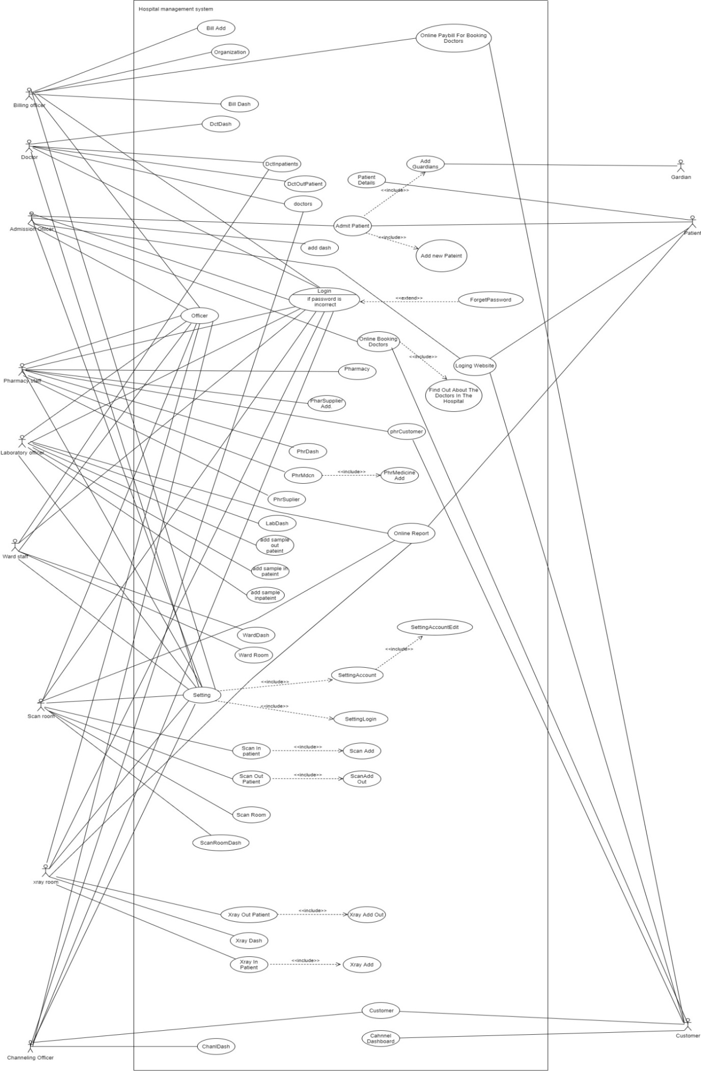 **2.4.2Activity Diagram**

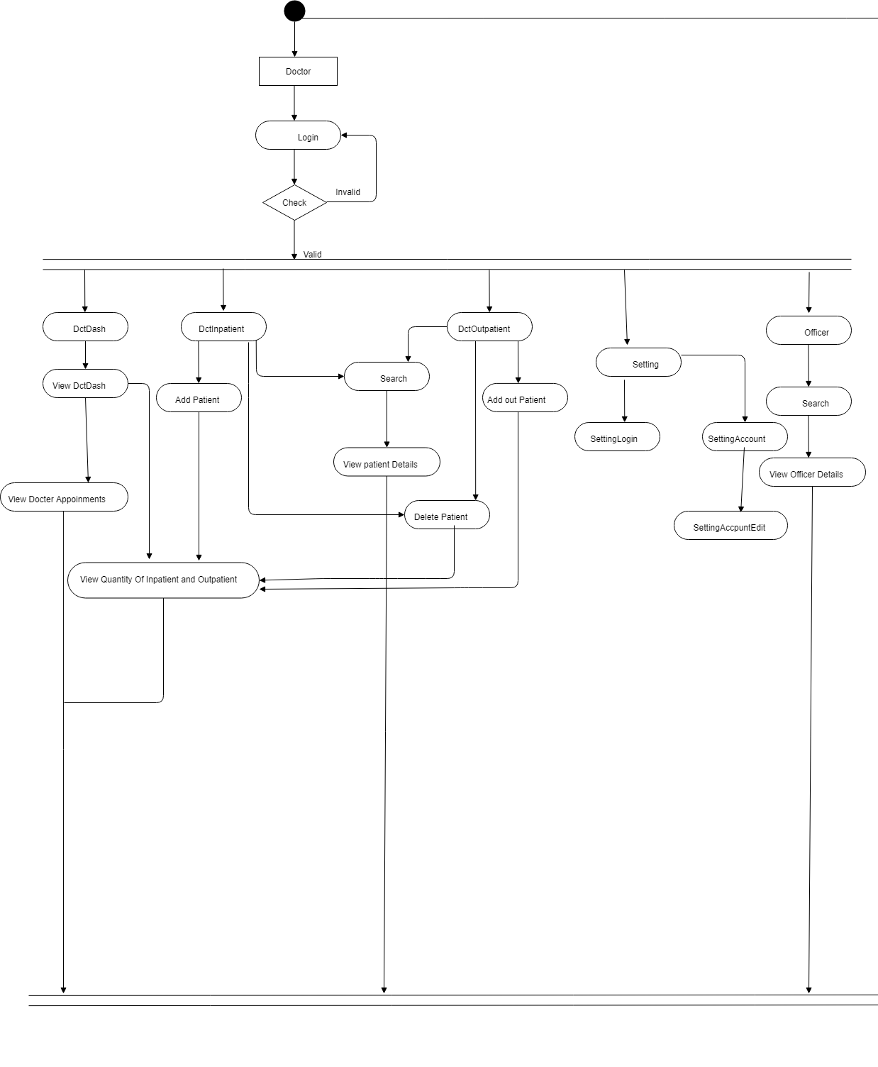

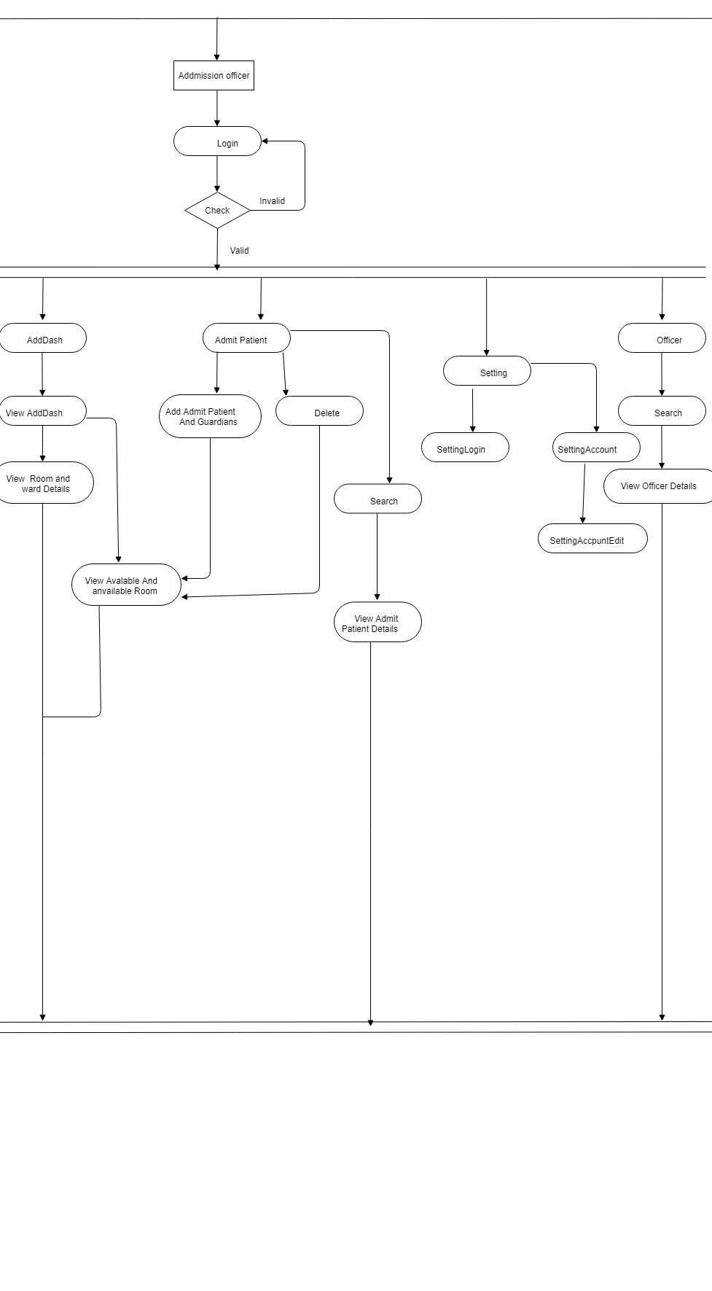

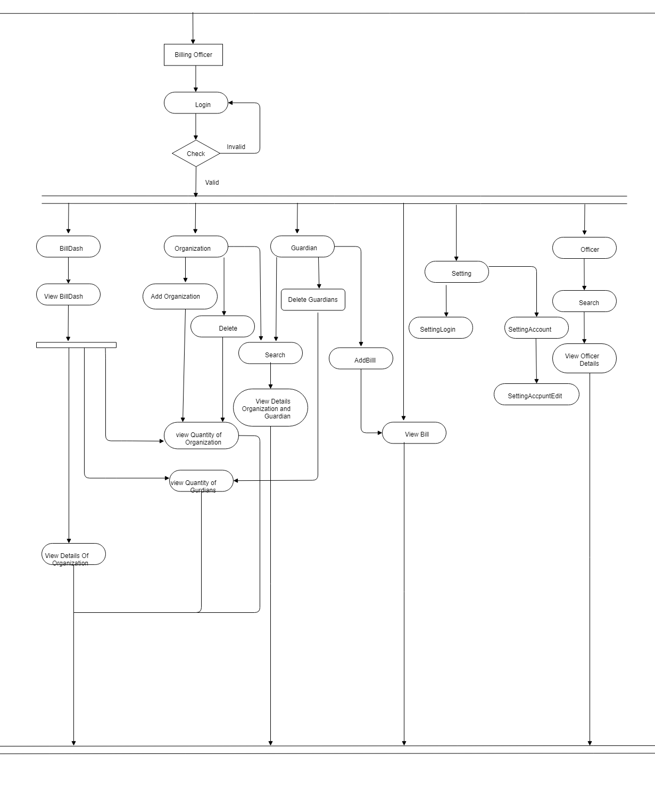

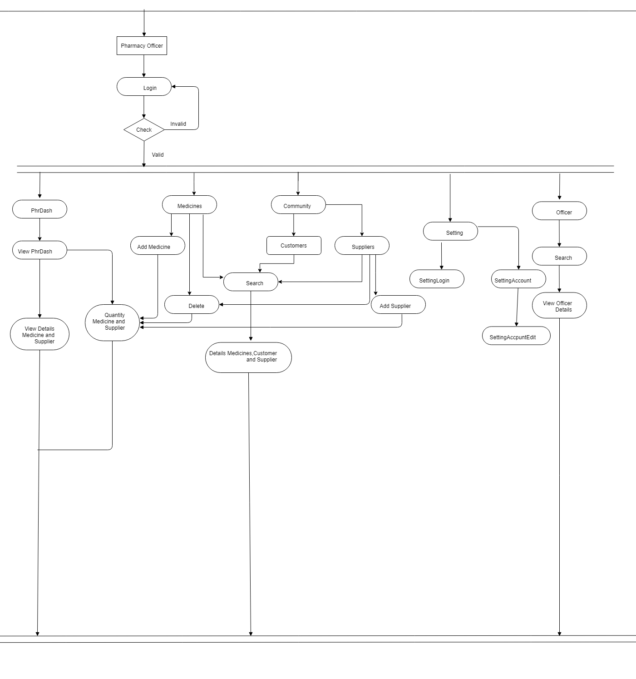

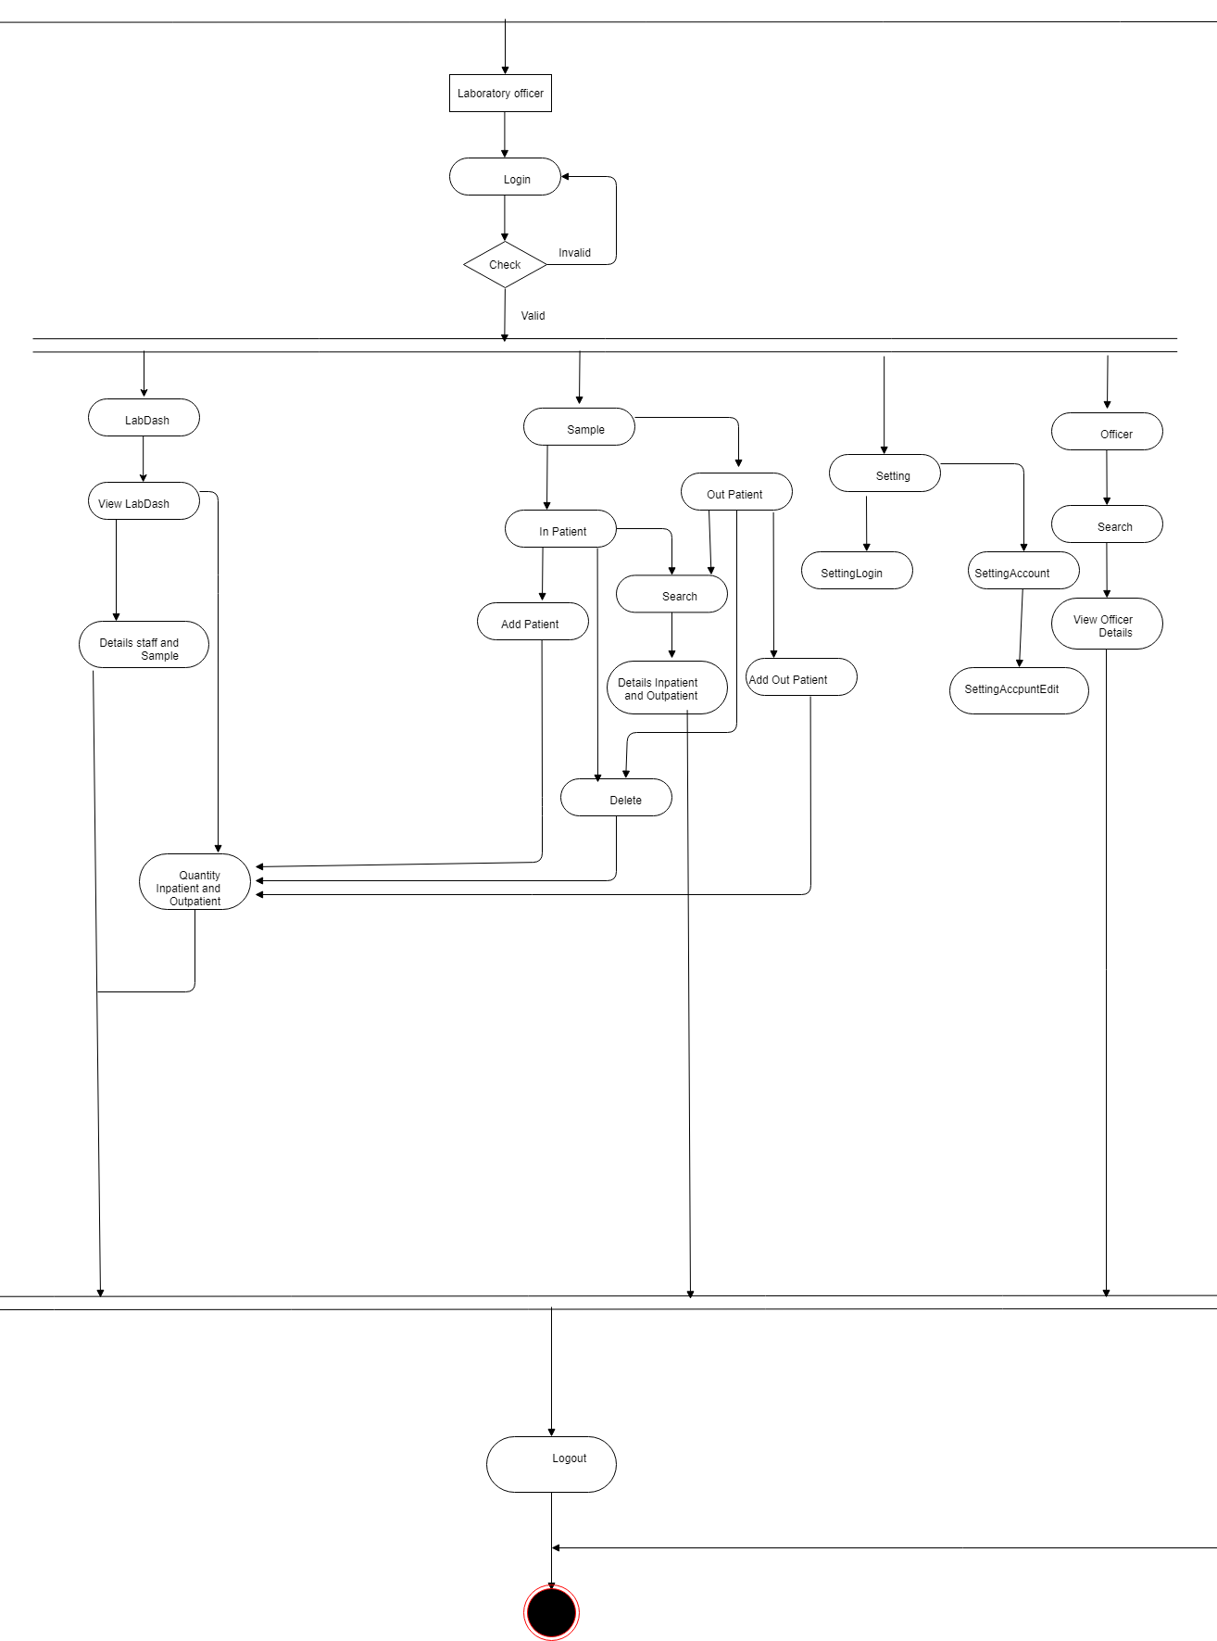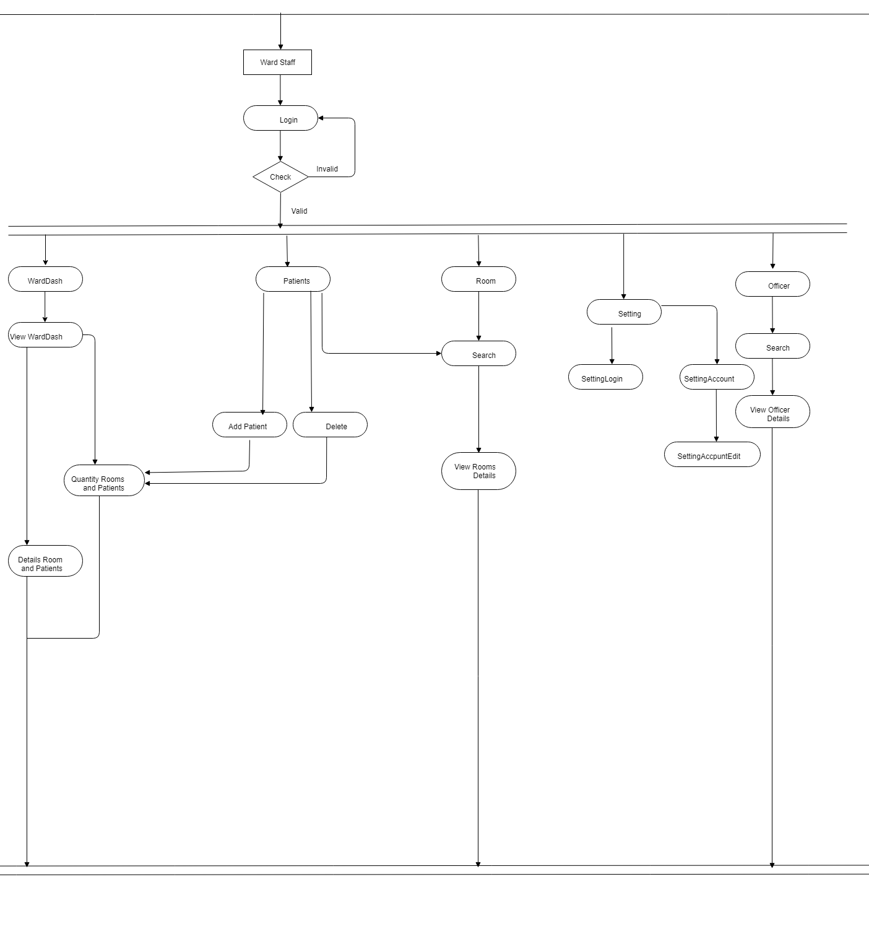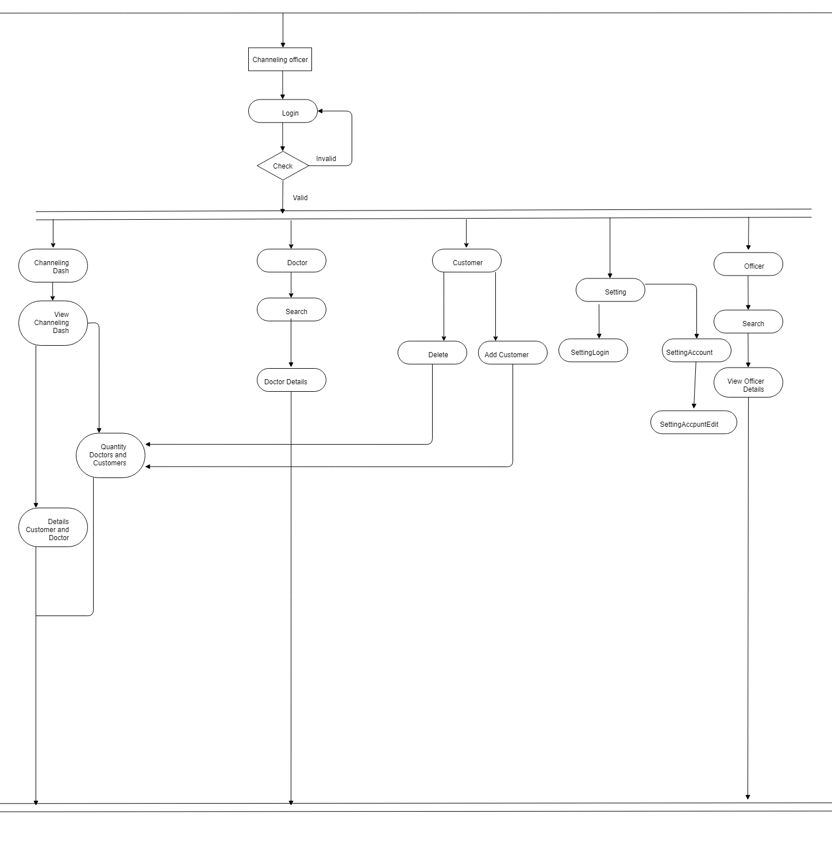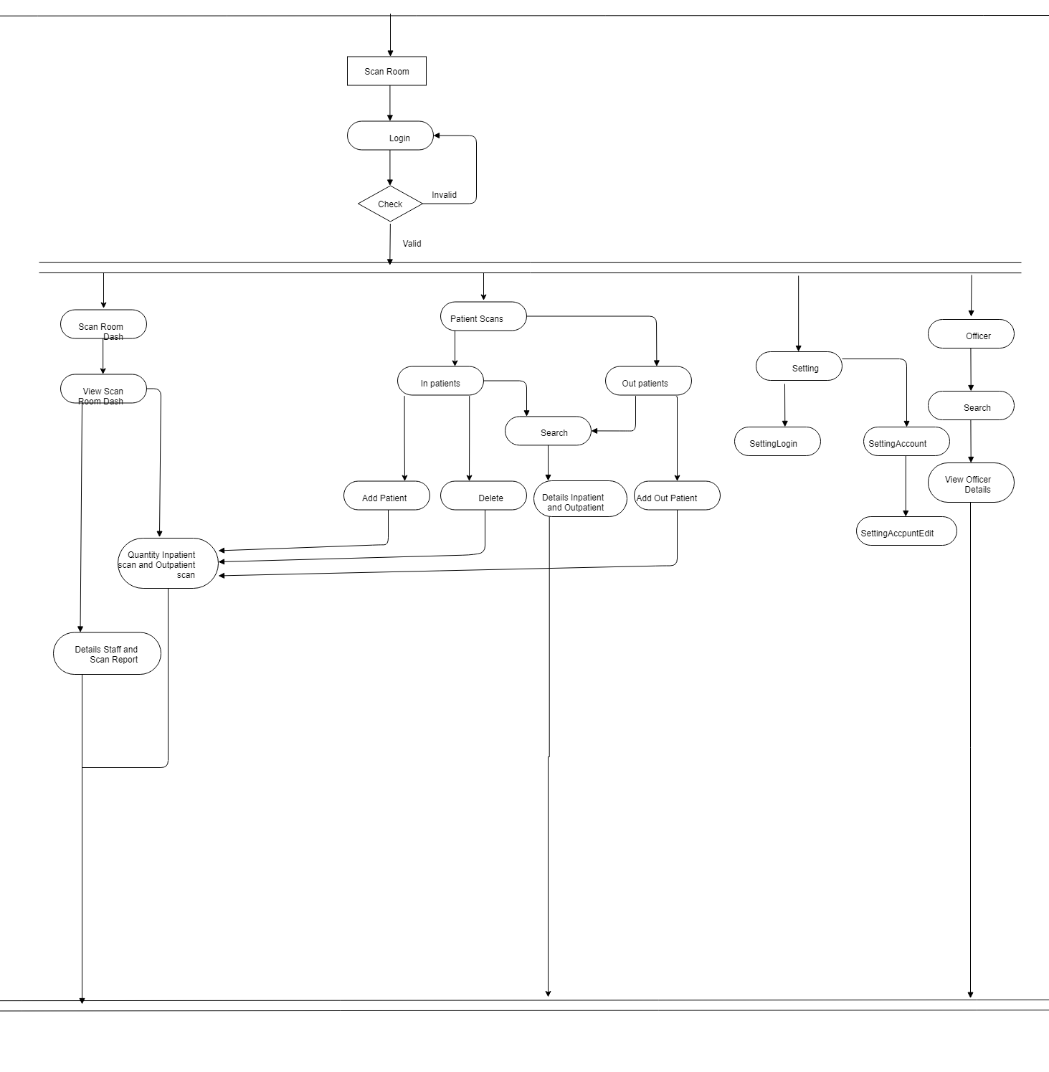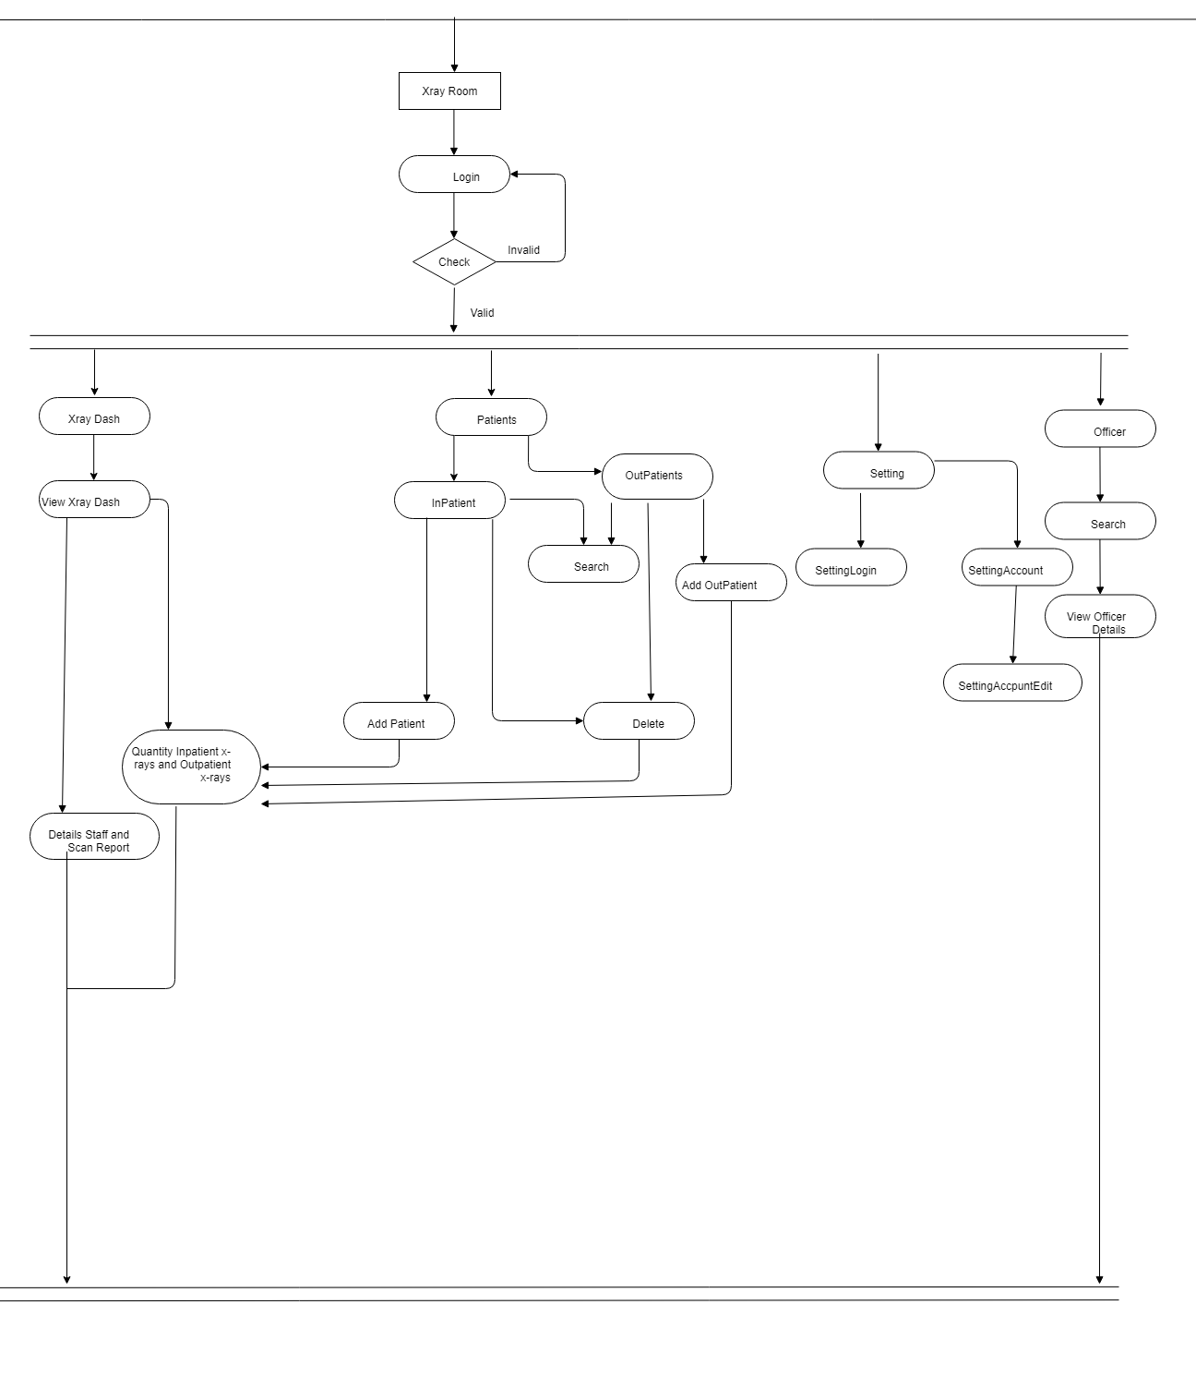

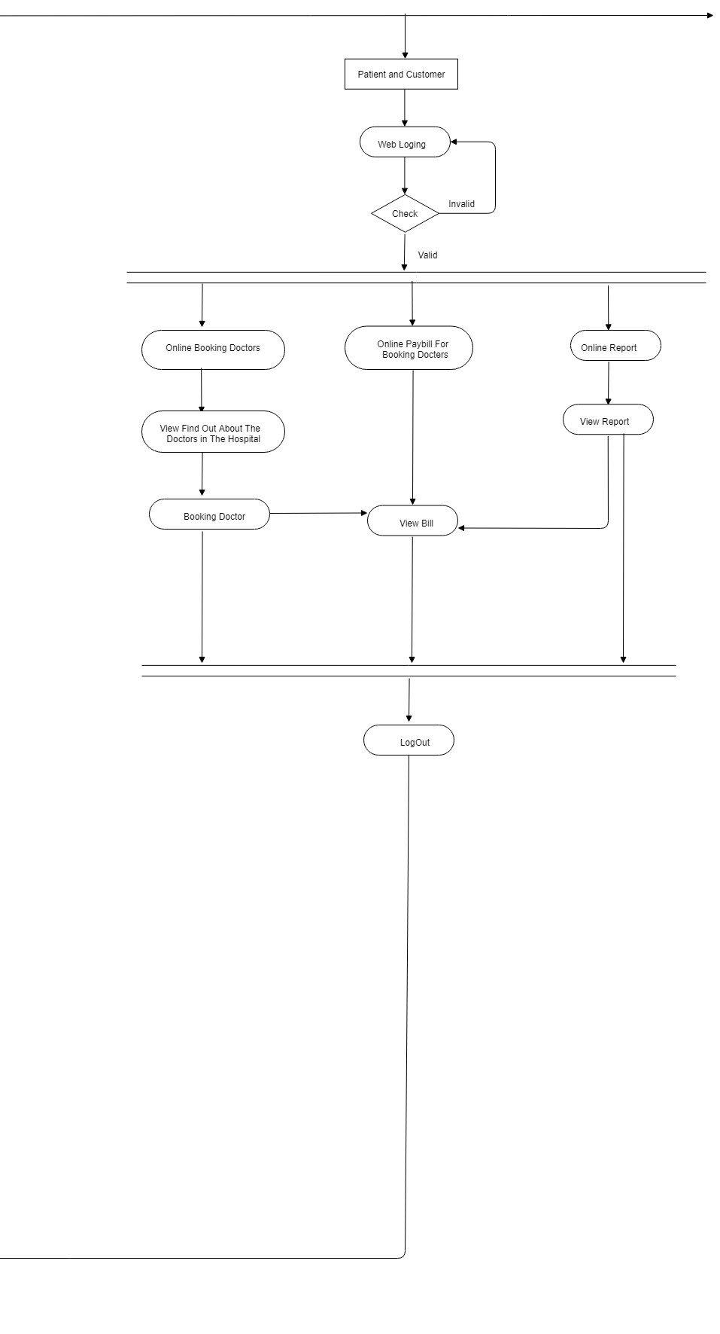

**2.4.3. Class Diagram**

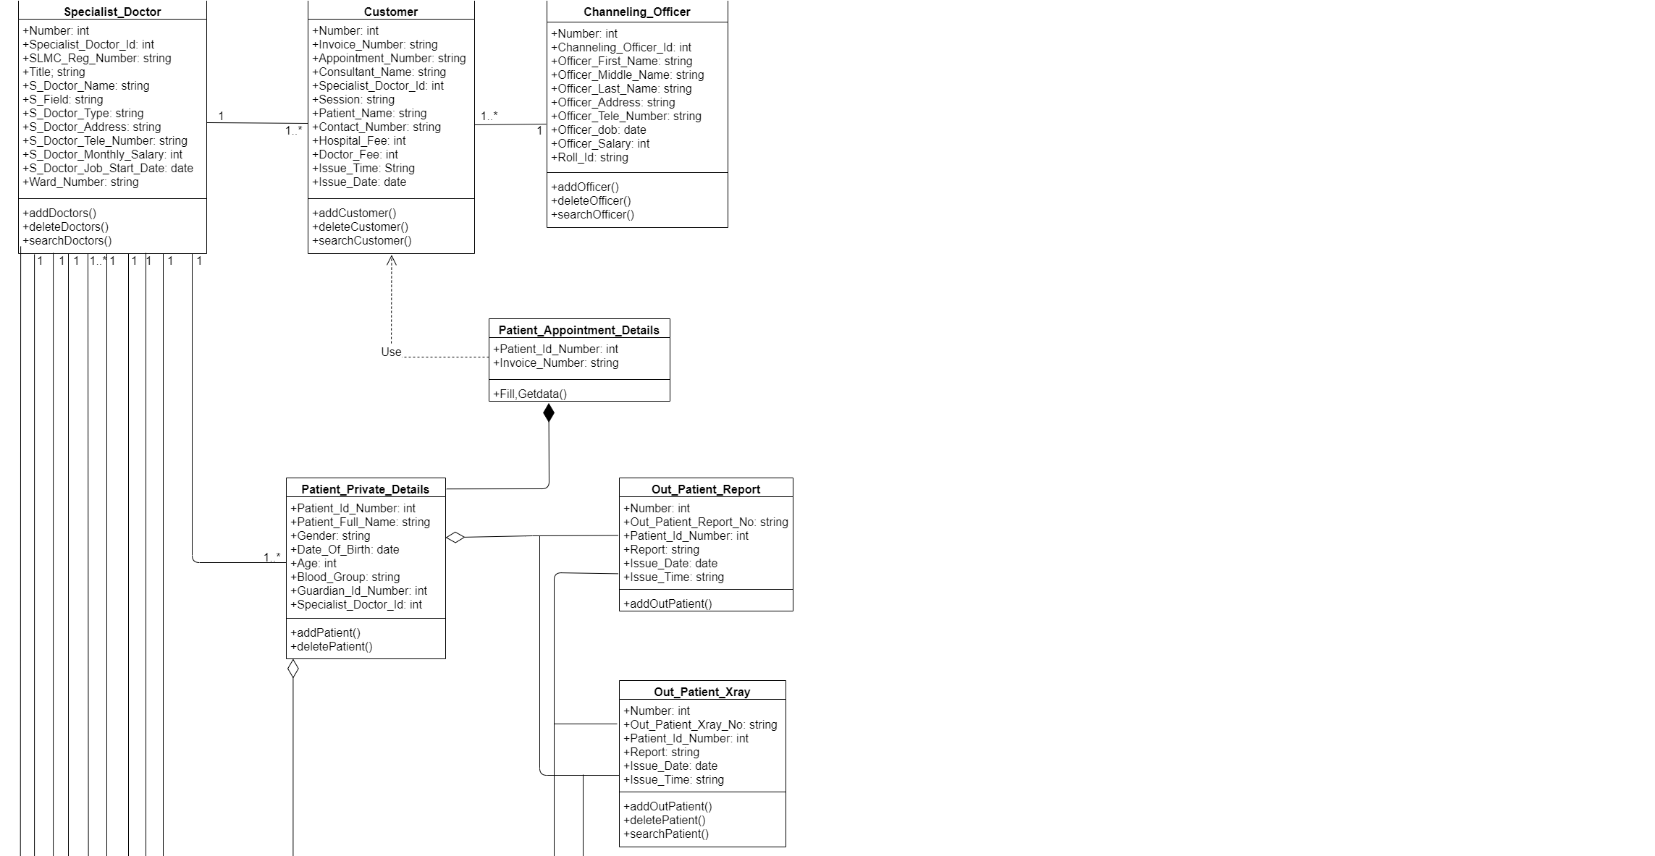

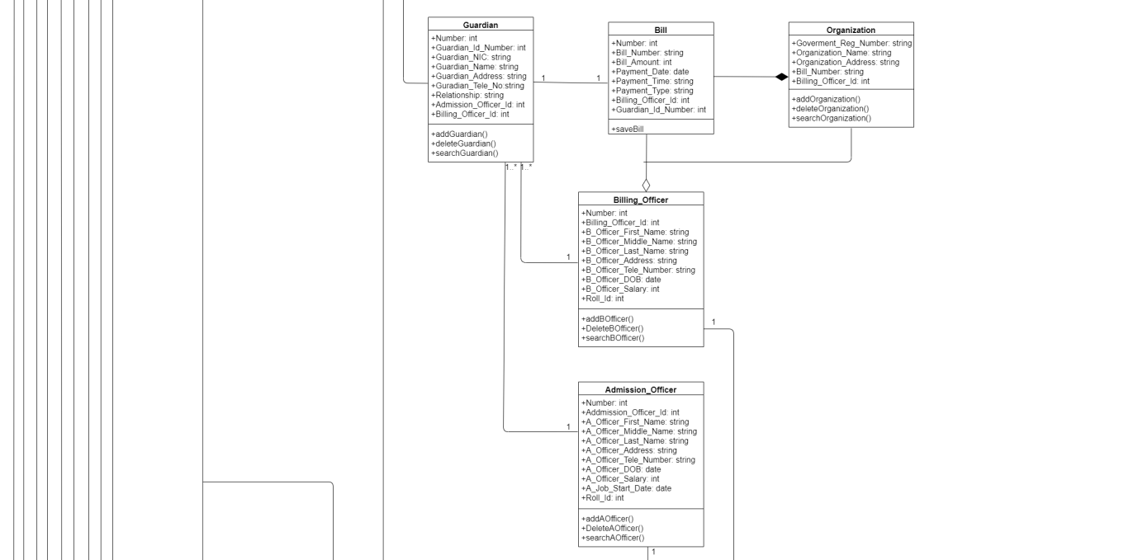

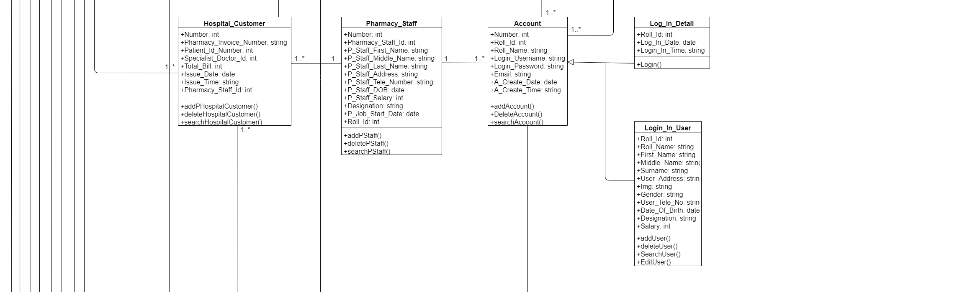

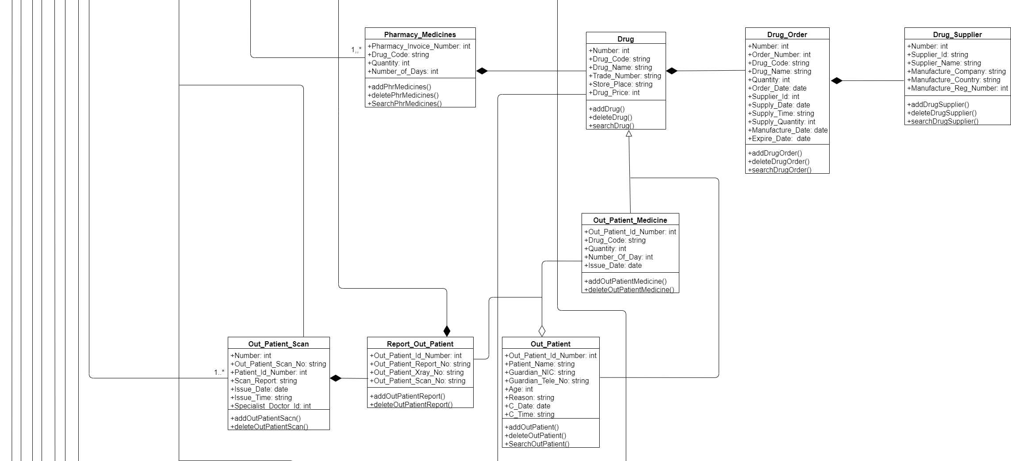

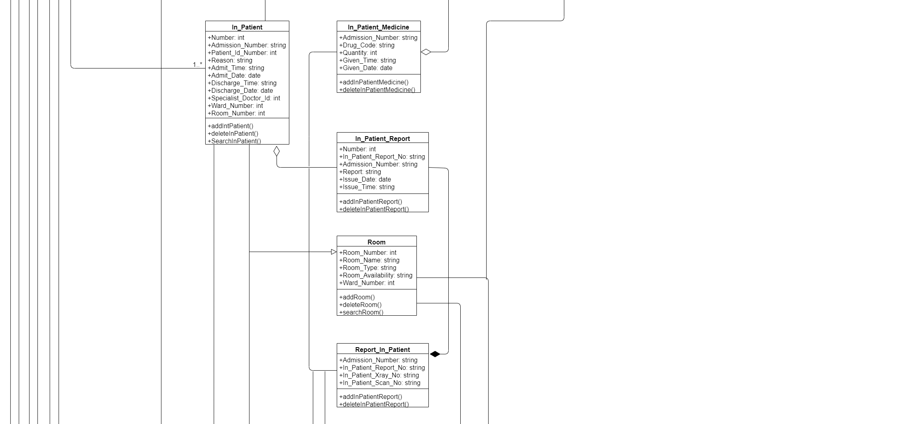

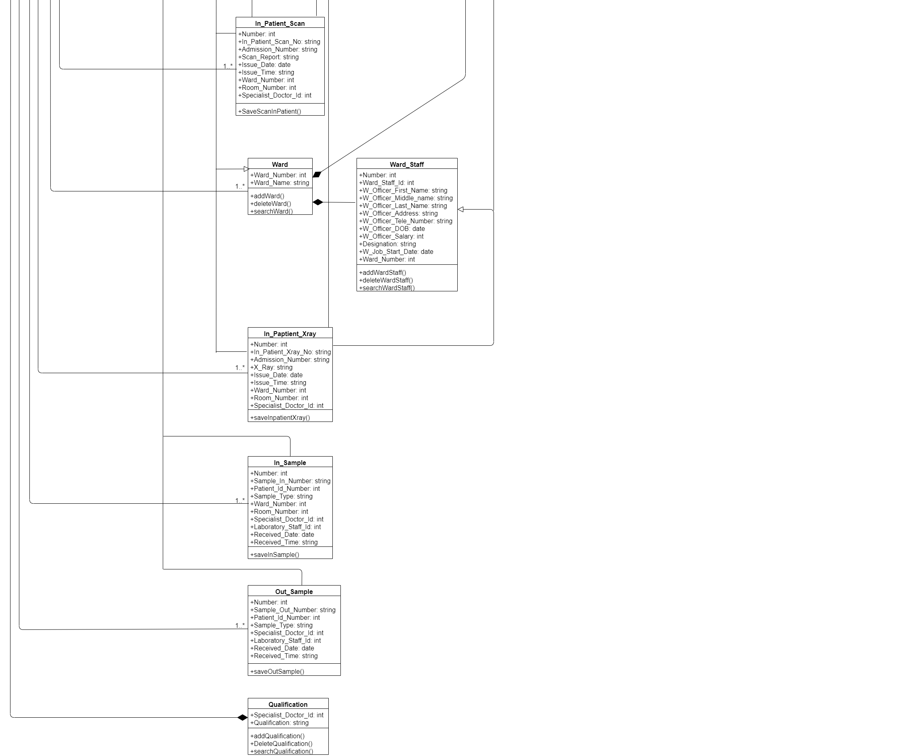

**2.4.4 Sequence Diagrams**

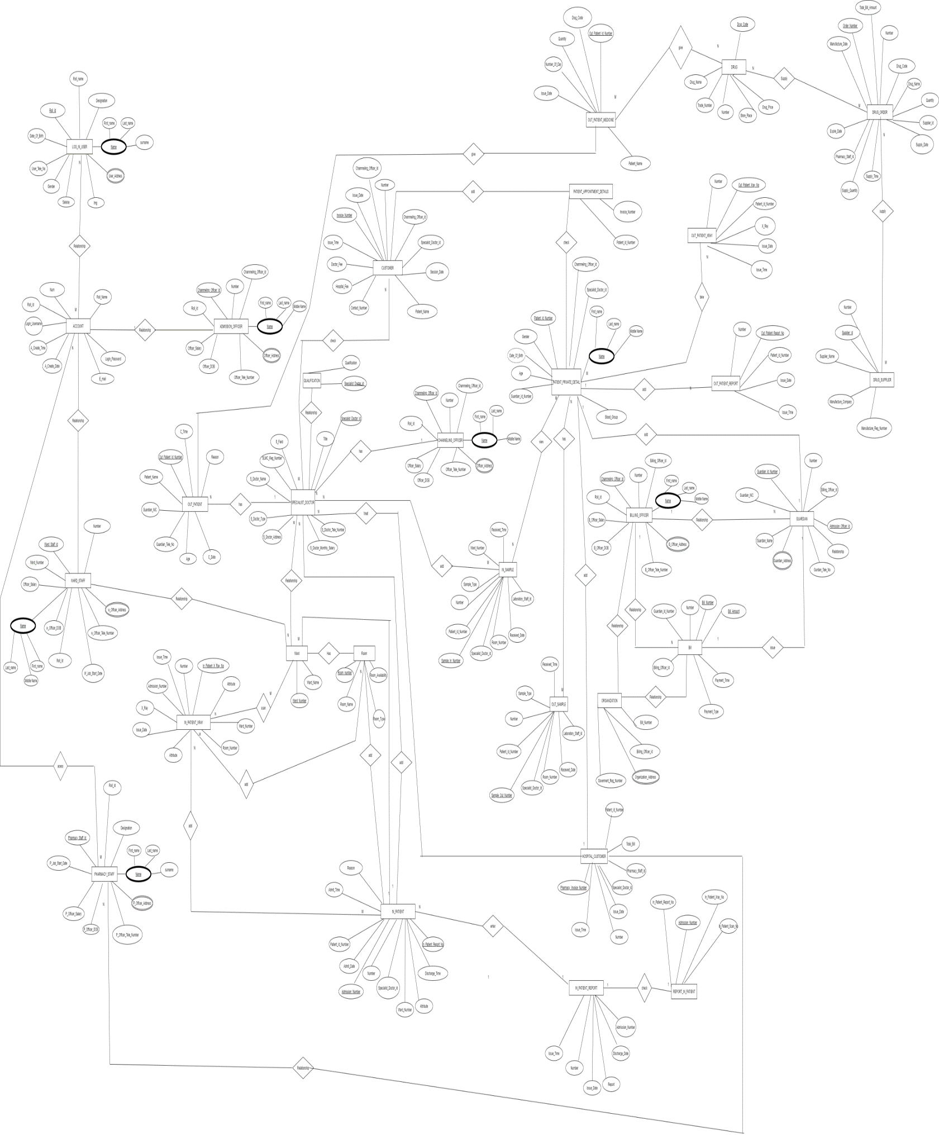2.4.5 ER Diagram

**Chapter 3**

**3.1 Design of proposed system**

**3.1.1 System Requirements**

Health Street Hospital Management system is web-based application and standalone application which handle the Hospital Management and administrative activities. Standalone application is implemented for Add patient, admit Patient, bill create, bill dashboard, change password, add channel customer, dashboard channel customer, channeling officer dashboard, add doctor, doctor dashboard, forgot Password, add guardians, add lab sample, dashboard lab sample, add pharmacy medicine, dashboard pharmacy details, add pharmacy suppliers, suppliers details, add scan room, scan room dashboard, add ward, ward dashboard, all account setting, add patient x-ray details, display x-ray details.

**3.2 Database Design**

**3.3 Interface Design**

* **Login Form -** This is the login form that all registered persons can login to the system by using their own username and password.

* **ADaddPatient Form-** This section is used to enter patient and patient guardian details. First Name, Middle Name, Surname, date of birth, reason and gender into patient. patient guardian details are name, Nic, Address, TP Number, Relationship, date and time.

* **AddDash Form-** Patients admitted to the hospital by this section shows the in Patient id number, Patient first name , Patient middle name, patient surname, Gender , Date of birth, Age, Blood Group, Guardian NIC, Guardian Address and Guardian TP No in in admit patient in the hospital.

* **Add New Patient-** This section is used to add new patient. Add to Patient Name, guardian TP No, Guardian NIC, Age , reason. And add the patient’s guardians’ details. The details are Name, Nic, Address, TP Number, Relationship, Date, Time.

* **Customer Dashboard -** This section is used to show the invoice Number, Appointment Number, Consultant Name , Specialist Doctor id , Session Date , Patient Name, Contact Number , hospital fee.

**Add Sample Inpatient –** This is used to add the x-rays to the system. x-rays are added by officers**.**

* **Add Customer *-*** This section shows add customer details. Details are Appointment Number, Patient Name, Session Date, specialist Name , Doctor fee , hospital fee , contact Number , Date , Time.

* **Room Dashboard** -This section Display the room details of the system.

* Forget password- Customized details all login users. Details are first Name, Last name, G-mail, New Password, confirm Password.

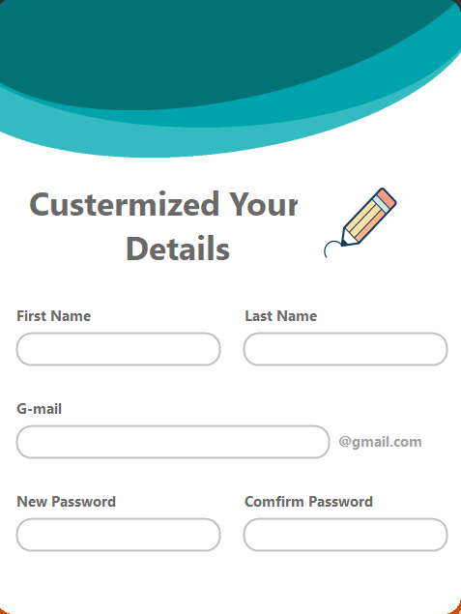

* **Channel Dashboard** – Display all details of the doctors and customers. Details are Special doctor id, Doctor Name, field, invoice Number, Appointment Number, Hospital fee, Doctor fee.

* **MessageQuestion Form** - This section use to Display the message of the yes or no.

* **Doctor Dashboard-**display doctor in-Patient , out-Patient and appoinments.

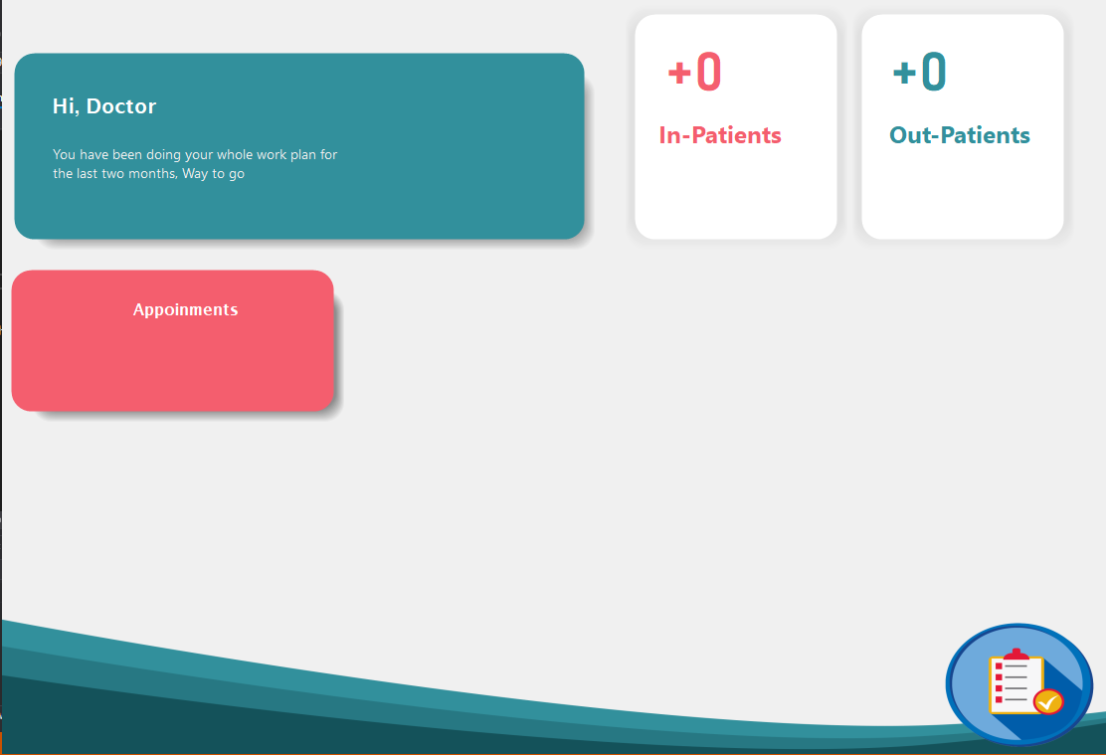

* **Doctor Inpatient** – Display and search in patient details.

* **DctPatient Form**-This section use to display and search admit patients in the hospital.

* **A picture containing table

  Description automatically generatedDoctor Form**-This section shows the details of the doctors working in the hospital. The details are First name, Middle Name, Surname, Gender, Address, TP Number, Designation, Salary.
* **Forgot Password Form-**This section use to change the password. Then enter the Gmail address and get code and reset your password.

* **Guardian Form -** This section is used to show the Guardians details. There are Name, NIC, Address, TP Number , Relationship ,date and time.

* **LabAdd Form –** This section is used to in the add to x-ray samples of the patient.

* **LabAddOut Form -** This section is used to in the out to x-ray samples of the patient.

* **LabDash Form -** This section use to display the all details of lab. Display to the Staff analytics and Patient analytics.

* **MessageError –** This section use to Display the message of the error.

* **Laboratory Form** - This allows you to access the dashboard, samples, staff, and settings sections of the lab.

* A picture containing table

  Description automatically generated**LabSmplInpatient Form –** This section use to display ,search , update , delete of the lab sample.
* **LabSmplOutpatient** - This section shows the full details obtained samples by the laboratories.

* **NewPassword Form -** This is used when changing the password.

